## Story ID 16: Coordinator Notifications

User Story: As the driver I want to be quickly notified about all circumstances and events that may affect deliveries so I can plan accordingly.

* From the employee login screen, I am able to log on as the coordinator and access the Coordinator dashboard.

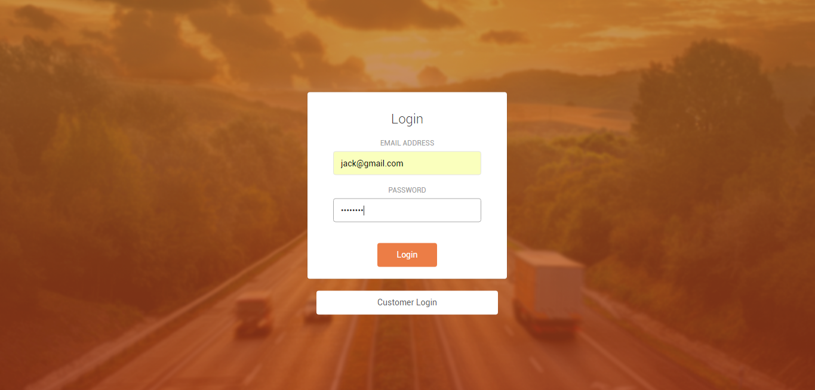

* From the Coordinator Dashboard, I am able to click on the notifications option present on the sidebar to access the notifications screen.

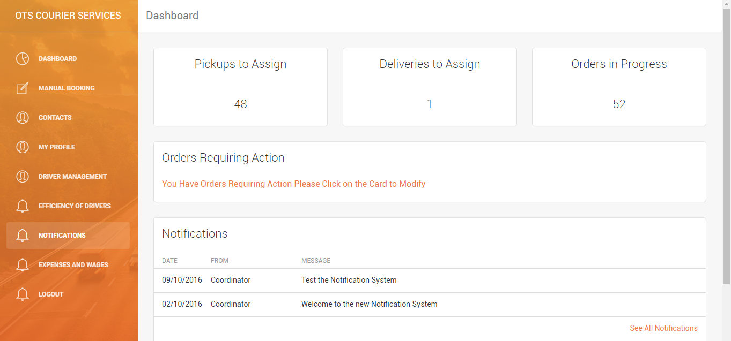

* On the notifications screen, I am able to view all notifications, and click on the 'New Message' button to access the Notification Manager page to send a new notification.

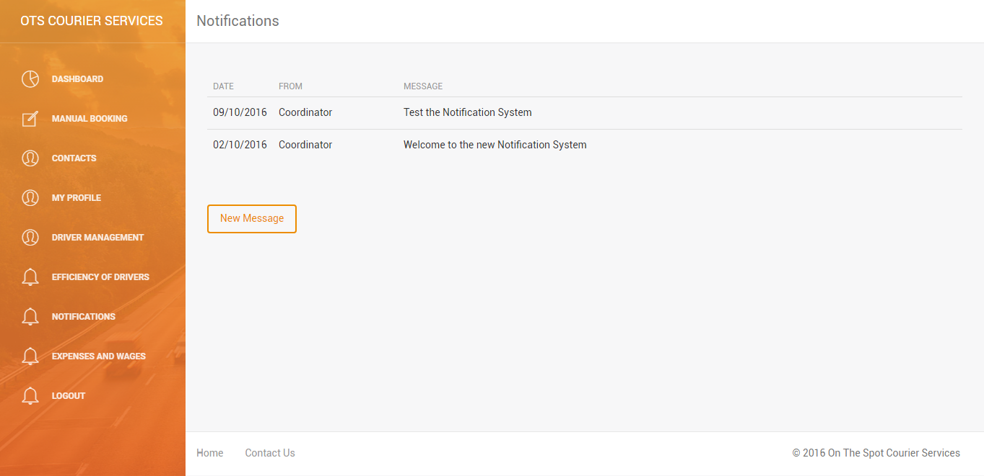

* On the Notification Manager screen, I am able to enter the contents of the message into a text box, then specify that this notification is a Coordinator notification. I am then able to specify that only drivers should receive this notification (with alternative options to send to all, customers or a specific person).

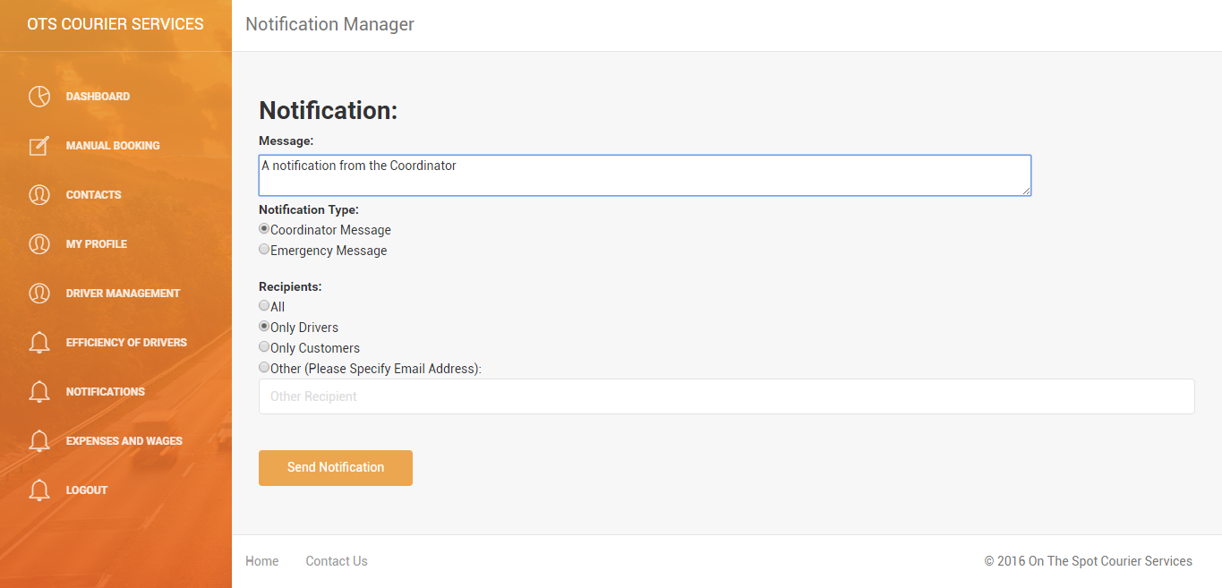

* Now, I am able to login as a driver, to access the driver dashboard and through it, the notifications screen.

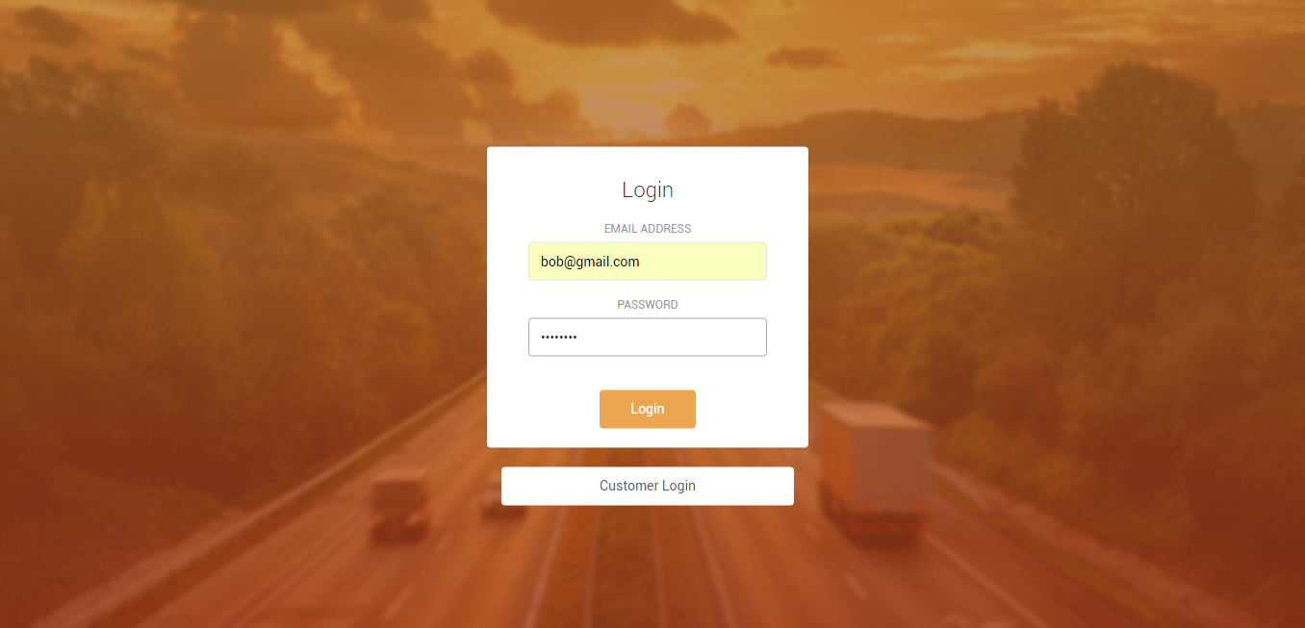

* From the notifications screen, as a driver, I am able to see the new notification sent by the Coordinator.

